**FYP MID Defense**

***Sukkur IBA University***

### Software Requirements Specification (SRS)

For

Online Scholarship Portal

Version [1.0]

Sagar Ali

Mahnoor Sadiq

Muhammad Farhan

Supervisor: Dr Fahim Akhtar Rajput

Date of preparation: 03-03-2022

|  |  |
| --- | --- |
| *Project Code* | F18-0025 |
| *Supervisor* | Dr Fahim Akhtar Rajput |
| *Co-Supervisor* | Khalid Hussain Detho |
| *Project Manager* | Sagar Ali |
| *Project Team* | Sagar Ali  Mahnoor Sadiq  Muhammad Farhan |
| *Submission Date* | 15 March 2022 |

#### *[Instructions]*

* *No section of template should be deleted. You can write ‘Not applicable’ if a section is not applicable to your project. But all sections must exist in the final document.*
* *All comments/examples mentioned in square brackets ([]) are in the template for explanation purposes and must be replaced / removed in final document.*
* *This’ Instruction’ section should also be removed in final document.*
* *MS-Word Reviewing feature must be used to get the document reviewed by PMs or supervisors.*

*Document History*

*[Revision history will be maintained to keep a track of changes done by anyone in the document.]*

|  |  |  |  |
| --- | --- | --- | --- |
| **Version** | **Name of Person** | **Date** | **Description of change** |
| 1.0 | Sagar Ali | 03-03-2022 | *[e.g. Document Created]* |
| 1.0 | Mahnoor Sadiq | 03-03-2022 | *[Added Non-functional requirements]* |
| 1.0 | Muhmmad Farhan | 03-03-2022 | *[Added UseCase x.x.xx]* |

*Distribution List*

*[Following table will contain list of people whom the document will be distributed after every sign-off]*

|  |  |
| --- | --- |
| Name | Role |
| Dr Fahim Akhtar Rajput | Supervisor |
| Khalid Hussain Detho | Co-supervisor |
| Sagar Ali | Project manager |
| Mahnoor Sadiq | Group Member |
| Muhammad Farhan | Group Member |

*Document Sign-Off*

*[Following table will contain sign-off details of document. Once the document is prepared and revised, this should be signed-off by the sign-off authority.*

*Any subsequent changes in the document after the first sign-off should again get a formal sign-off by the authorities.]*

|  |  |  |  |
| --- | --- | --- | --- |
| **Version** | **Sign-off Authority** | **Project Role** | **Sign-off Date** |
| 1.0 | Dr Fahim Akhtar Rajput | Supervisor |  |
| 1.0 | Khalid Hussain Detho | Co-Supervisor |  |
|  |  |  |  |
|  |  |  |  |
|  |  |  |  |
|  |  |  |  |
|  |  |  |  |

Table of Contents

Software Requirements Specification (SRS) 1

1.0 Introduction 5

1.1 Purpose of Document 5

1.2. Intended Audience 5

1.3. Document Convention 5

1.4. Project Scope 5

1.5 Not in Scope 6

2.0 Overall System Description 7

2.1 Project Background 7

2.2. Project Objectives 9

2.3. Stakeholders 10

2.4. Operating Environment 10

2.5. System Constraints 10

2.6. Assumptions & Dependencies 11

3. External Interface Requirements 11

3.1. Hardware Interfaces 11

3.2. Software Interfaces 11

3.3. Communications Interfaces 11

4.0. Functional Requirements 12

4.1. Functional Hierarchy 13

4.2. Use Cases 14

4.2.1. Student Module. 14

4.2.2. Donor 20

4.2.2. Admin 27

5. Non-functional Requirements 31

5.1. Performance Requirements 31

5.2. Safety Requirements 32

5.3. Security Requirements 32

5.4. User Documentation 33

6. References 34

# 1.0 Introduction

Project Online Scholarship Portal is a web-based portal that is web-based portal to help students and the stakeholders in the process of scholarship applying and processing. The main purpose of this document is that providing easiness to the students and the scholarship vender in the whole process of the scholarship. Normally, the process of applying and evaluating is done on the papers and this takes lots of human efforts and energy to process a single scholarship. This also leads to redundancy of the data, increases search time for the list of students that are selected for a particular scholarship and this list goes on. The vender/scholarship doner also does not knows about the students to whom they have given the scholarship either they are still studying or they have left university. Also the students have to apply again and again for the same requirements of different scholarships. These all issues will be solved by developing an online portal for the applying and processing these scholarship applications.

This is completely a Web-based project as the hardware like Desktops or mobile devices enabled with browsers are needed to access the website. Without the web browser, the access to the website is not possible.

## 1.1 Purpose of Document

This document provides the complete requirements for this project. The document is intended to provide the complete scope, objectives, outcomes, operational environment and assumptions or dependencies related to the proposed system. Also this document presents complete functional and non-functional requirements of our system.

1.2. Intended Audience

The intended audience for this document is the development team, project supervisor and the FYPC (Final Year Project Committee) or the evaluation committee of this project.

## 1.3. Document Convention

The font of the document is the Times New Roman and font size will be 12. The headings will be selected from styles i.e. Heading 1 or Heading 2. The line space is 1.5 after every heading and the text is justified

## 1.4. Project Scope

As we are proposing such a system that will rectifies maximum problem persisted in the existing system that are currently running in many university so our project scope is not for any specific single university but for any university who want to replace the paper-based system with web-based system.

This project is web-based which will have following function:

* Admin will allow student and Vendor/Scholarship donor for registration
* Scholarship Donor will donate scholarship
* Students have to check on the base of certain criteria, that is specified by donor, whether it meets or not with student’s criteria.
* If meets criteria, Students will register themselves.
* System will filter out from the Registered student’s list and separate them who meet the scholarship criteria.
* Notification or Email will be send to students for further step like taking interviews
* Then they can be notified by system, when Student are awarded with scholarship.
* When student will be availing scholarship, Donor can have a list of that students, to check whether they are still continue with that scholarship or not.

## 1.5 Not in Scope

* Auto filling Form.
* No Google Form.
* Android Application.

# Overall System Description

## Project Background

In this recent era, almost everyone is having financial crises and every person wants to admire a good education. Most of the students leave/drop their study because of financial crises, and they even don’t know about the scholarships or how to apply for applying for scholarship properly. The current era is the era of technology and computers, every manual processing at large organizations is replaced by smart or online portals. Nevertheless, the processing of these applications takes lot of time and applicants have to fill forms manually and send them to the scholarship granting offices. For processing of single application, lots of human effort and time is required. In such a digitalized and computerized world, there is a much need of online platform for the applying and grading scholarship. The scholarship donor doesn’t know about the students whether they are still availing scholarship or not so, that scholarship donor can also monitor the status of student’s scholarship.

The most commonly used system for this purpose are the **HEC Ehsaas Portal** [1] and the normal manual processing. Here the human resources needed for the fill process and grade scholarship are way too long. In the case of Ehsas portal has limited scope and it only allows to apply only for the single. Also it is only for the submission of applications and the grading for the student is done by the admin, and there is no any tracking point from HEC EHSAAS for the students who are awarded with scholarship to check whether they are still availing or not. The human effort needed for the system is less as compared to the manual human working but resources are needed. The students get unmotivated by filling forms again and again for same types of scholarships.

Like in the existing system named **E-scholarship System** [2], they provides students of Niger state to apply for scholarship online with the Niger State Scholarship Board. This system is implemented only to allow students of Niger to apply for scholarship. This system had resolved some issues like waste of time in paper-based processing for scholarship application, resolved the issue of errors which is difficult to resolve in paper-based form. The issue of this kind of platform will not be suitable if we have to purchase it and as we are about to propose a system that need a central admin that will handle, manage all our data and it is not a useful when compared to portability of software.

Like, another, in the **University of Wisconsin-La Crosse** [3]**,** they just provide the desktop-based Application which is developed a system that is helping students, committee members and admin to process, manage, and to let student fill forms efficiently. The limitation of this paper is that it is completely **Desktop Application** and its portability is major concern. If we want services like Desktop, the issue for admins and committee members almost can be solved but the major issue will be for the students who may not own the laptops or desktops.

There are also other platform that is provided, but those are mobile based which also provide the facility of online process of scholarship form filling. Such as following few of mobile based platform:

* **Bright Scholarship** [4]**:**

This applications allows students to apply for any level of scholarship for abroad. It just provide like advertisement scholarship and redirect to link when user visit that ads, as well as it also give facility of offering the course.

* **Scholarship for International Students** [5]:

This application allows students to view the list of scholarships and then apply for them by clicking on link that will redirect to web-based platform for applying scholarship and the complete details of studies is included on the webpage as well as on mobile platform.

* **National Scholarship Portal** [6]:

It is platform for Indian students for applying scholarships. Here students can register for new scholarships and see the status for previous record of scholarships that for they have applied.

* **Scholarship Home** [7]:

Like Full Scholarship for International students, this app has the same policy for applying for scholarships. It also includes the list of subjects that may a student study at the university.

* **Global Scholarship** [8]:

This is other kind of application that allows students to apply for the scholarships. They have to register for particular scholarship and if they have any vacancy, they call students by call or by the email.

* **Scholly: College Scholarships** [9]:

This application is completely mobile based and upon successful login to application, the student is asked for the completely fill the form including all basic details.

* **Scholarship In Pakistan** [10]**:**

This application is too simple, it just provide the information that what kind of scholarship are available, scholarship list in the scope of Undergraduate, Master, PhD and so on. In this app functionality, there is no any information is collected nor any application of scholarship is filled. This app just provide list of scholarship’s name

* **Scholarships** [11]**:**

This scholarships app provides different nature of scholarship according to country. It gives information of all `type of scholarship whether it is in master, PhD, or graduate level as well as for international students. It let student to search and filter scholarship on the base of its needs or criteria like local-wise or country-wise scholarship. When students finds any scholarship, then this app redirect to scholarship’s page.

Mobile-Based Application is hectic for filling the form and monitoring, managing the scholarship query and so on, Basically this type of mobile-based platform are suitable just to notify the user for scholarships, that can play a role of aware the user for scholarships.

So what is missing in all these projects/systems? There is no awareness about the scholarship to students, nor can Scholarship Donor / Vendor monitor who are awarded with scholarship nor can meets and get the feedback from the students. Some of the systems are only based on the web based that are too old and taking time efficient and they are not suitable for today’s robust and complex systems and the mobile applications are not going to be able to help the students in good way. So in order to remove all these complexities and problems, our system will handle all these problems and remove all the difficulties, and will rectify the maximums problem.

## 2.2. Project Objectives

The Objective that is measured and need to achieve in order to rectify the problems that are following:

* **Manual to online processing of Scholarship applications**

Main motive of this web-based system is to solve, rectify the problem of wasting paper, redundancy of data, noting the student’s record in book register.

* **Reduce human effort.**

There is major concern is human health that is wasted during managing, arranging, monitoring the thousands of students records that is hectic for human.

* **Reduce workload for staff and students**

Having online system for scholarship, it will rectify the main problem that is workload of arranging the sessions for to give awareness of scholarship to students and managing the numerous of queries of students.

* **Easy processing of Scholarship**

There will be easiness of managing records, arranging sessions, monitoring and checking scholarships of students, that al can be handled by having Online Web-based system which increase in easiness, reduce the effort of staff as well as students.

* **Enhance efficiency**

Processing a single application is efficient and enhance able process, but if we consider thousands of application of its monitoring, and checking required more efficiency and need improvement in existing paper-based system.

* **Reducing time for searching data of scholarship granted students**

Searching a scholarship which meets the criteria with students is major issue that need to be tackle because students are properly aware of scholarships that is offered by any university, so students and institutes need a platform where scholarships are posted and students can see and check their scholarship which meets their criteria**.**

After attaining these all objectives, System will provide the easiness process, manageable records, arrangable sessions like posting an ads of scholarship in platform to aware students, and can be monitored from both perspective that is administration and Scholarship Donor/ Vendor having awarded scholarship to students.

## 2.3. Stakeholders

The stakeholders of the system are following:

* Supervisor/Co-Supervisor/Project Manager
* FYP Evaluation Committee
* Development Team (Every member of our team will be a stakeholder of project)
* Vendor/Scholarship Donor
* Student
* Organizations (Any organization can use this project in their buildings)

## 2.4. Operating Environment

As it is a web-based system, so the platform or environment that is required to operate are following:

* **For Hardware Environment**: To run system, there should be any Computer, Mobile device or tablet.
* **For Operating system Environment**: As the project is web-based, so any operating system is applicable because the system will be running over browser. The system will be designed using some tools listed below.
  + Node.JS for backend development of website.
  + HTML, CSS, JavaScript and Bootstrap and React.JS.
  + MYSQL Database for data storage.
* **For Network Environment:** Network connectivity is necessary for system so that any activity can be perform in system.
* **Browser supporting HTML5**

## 2.5. System Constraints

*[Describe the constraints imposed on the system by the external environment. External environment may be caused by the stakeholders, business conditions, technical issues, academic requirements etc and may include the following:*

1. **Software constraints:**

* Browser should be compatible as HTML 5.
* Network interruption can be issue for responsiveness of application and be caused to time response.

1. **Hardware constraints:** User should have any of them such as Laptop, Computer, and Mobile enabled with web browser.
2. **Cultural constraints (includes language etc.)**

* System will be in English so user has at least knowledge of English
* The privacy of student data is strictly ensure.

1. **Legal constraints:**

Not Applicable

1. **Environmental constraints:**

Not Applicable

1. **User constraints:**

* System will be deployed in universities.
* Every User of System, somehow knowledgeable about English
* Students

## 2.6. Assumptions & Dependencies

* User has knowledge of browser and have an interaction with technology like computer, laptop, or mobile.
* It is assumed that user has an internet connection.
* It is assumed that user has a compatible browser.

# 3. External Interface Requirements

## 3.1. Hardware Interfaces

*[Describe the characteristics of each interface between the software and hardware components of the system. This description might include the supported device types, the nature of the data and control interactions between the software and the hardware.]*

As the project is completely web-based, so the costing is not a big issue in this project. The only costing is of the devices over which the web browser can run. Typically, the desktops, mobile devices or the tablets can be used supporting HTML5.

## 3.2. Software Interfaces

*[Describe the connections between this system and other external software com ponents (identified by name and version), including databases, operating systems, tools, libraries, and integrated commercial components. Identify and describe the purpose of the data items or messages exchanged among the software components. Describe the services needed and the nature of the inter-component communications. Identify data that will be shared across software components. ]*

## 3.3. Communications Interfaces

* **Architecture**: System shall follow the client-server architecture for communication.
* **Protocol**: System shall use HTTP protocol to communicate over the internet. TCP/IP networking protocol shall be used
* **Browser**: Any browser that supports HTML and JavaScript shall be used as client-server communication interface.

*[Describe the requirements associated with any communication functions the system will use, including e-mail, web browser, network communications standards or protocols, electronic forms, and so on. Define any pertinent message formatting. Specify communication security or encryption issues, data transfer rates, and synchronization mechanisms.*

# 4.0. Functional Requirements

As a student:

* The system should allow students to see the ads for the scholarships that are still open to the students.
* The system should allow the student to login and sign in for the applying the applications of scholarships
* The system should allow student to contact to the admin or the donor if he/she faces any issue wile filling scholarship form.
* The system should also show student in which particular scholarships he has already applied.

As a Donor:

* The system should allow the donor to post any Scholarship.
* The system should also facilitate donor to see the previous record of students who have applied for scholarship.
* The system should allow admin to chat with the admin if faces and difficulty in management of scholarship.
* The system should allow donor to grade student after the short listing and the final Interview of scholarship.

As an admin:

* The system should allow the admin to handle the issues that are faced by the student or the donor of scholarship.
* Admin should authenticate the donor for posting the scholarship.

## Admin should block the donors that have fake intention to donate scholarships. 4.2.1. Student Module.

Use Case Diagram

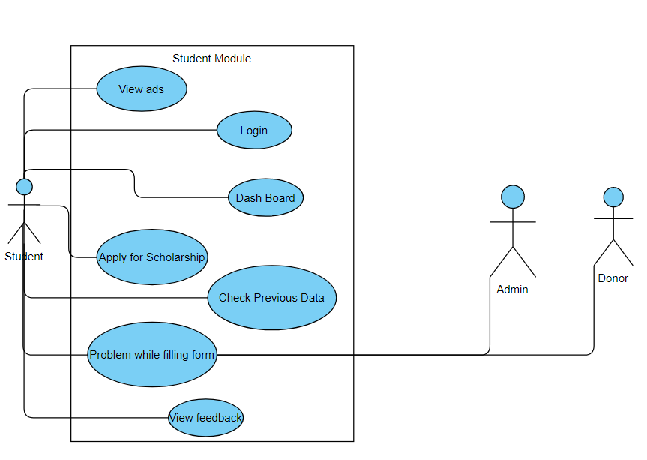

Use Case Description

1.1 Login and Sign up to application

|  |  |  |  |  |
| --- | --- | --- | --- | --- |
| Login and Signup to application | | | | |
| ***Use case Id:*** | | 1.1 | | |
| ***Actors:*** Students of universities | | | | |
| ***Feature:*** Login and signup to application for applying or viewing previous records. | | | | |
| ***Pre-condition:*** | | 1. For user to login, student must have username and password. 2. For signup, user must have an active mobile number and email account for versification of account. | | |
| ***Scenarios*** | | | | |
| ***Step#*** | ***Action*** | | | ***Software Reaction*** |
| ***1.*** | Enter username and password for applying scholarship | | | Username and password must be validated from the database and |
| ***2.*** | Enter first name, last name , username, mobile number and email for sign up. | | | The system will send OTP to mobile number and the email address for the verification. |
|  | Enter for forgot password | | | The system should send an OTP to mobile number or email in order to reset password |
| ***Alternate Scenarios:*** Write additional, optional, branching or iterative steps. Refer to specific action number to ensure understandability. | | | | |
| **1a:** Redirect user to the login page and show error message or notify with the message with cause of unsuccessful login.  **2a:** Shows error message if the course already exists in database. | | | | |
| ***Post Conditions*** | | | | |
| ***Step#*** | ***Description*** | | | |
| 1 | User will be logged in the system. | | | |
| 2. | Account will be created for the user after successful authentication through email and mobile number OTP. | | | |
| ***Use Case Cross referenced*** | | |  | |

1.2 Viewing posts related to scholarships.

|  |  |  |  |  |
| --- | --- | --- | --- | --- |
| **Viewing posts related to scholarships.** | | | | |
| ***Use case Id:*** | | 1.2 | | |
| ***Actors:*** Students of Universities | | | | |
| ***Feature:*** Viewing Scholarship ads and viewing details related to particular scholarship. | | | | |
| ***Pre-condition:*** | | User must be logged in to the system in order to provide security of system. | | |
| ***Scenarios*** | | | | |
| ***Step#*** | ***Action*** | | | ***Software Reaction*** |
| ***1.*** | View ad for scholarship. | | | System must provide functionality to the actor for viewing post time by time. |
| ***2.*** | Click on ad to see full details. | | | System must redirect user to the new window for viewing full datils of scholarship. |
|  |  | | |  |
| ***Alternate Scenarios:*** | | | | |
| **1a:** Redirect user to the login page and show error message or notify with the message with cause of unsuccessful login.  **2a:** Shows error message if the user clicks on an ad whose date has already passed | | | | |
| ***Post Conditions*** | | | | |
| ***Step#*** | ***Description*** | | | |
| 1 | User will be viewing the details of scholarships announced and which scholarships will be announced next. | | | |
| 2. | The user will be getting full knowledge | | | |
| ***Use Case Cross referenced*** | | |  | |

1.3 Applying for any scholarship.

|  |  |  |  |  |
| --- | --- | --- | --- | --- |
| Applying for any scholarship. | | | | |
| ***Use case Id:*** | | 1.3 | | |
| ***Actors:*** Students of Universities | | | | |
| ***Feature:*** Applying for a scholarship, filling form by accessing web link. | | | | |
| ***Pre-condition:*** | | User must be logged in to the system in order to provide security of system. | | |
| ***Scenarios*** | | | | |
| ***Step#*** | ***Action*** | | | ***Software Reaction*** |
| ***1.*** | Getting user details related to any scholarship. | | | Data will be entered and saved to the database |
| ***2.*** | Submit application form at the end | | | The system will send a conformation message to the user and will be short list students based on given criteria. |
| ***Alternate Scenarios:*** | | | | |
| **1:** Redirect user to the login page and show error message or notify with the message with cause of unsuccessful login.  **2:** Shows error message if the data related to any field is incorrect.  3: Show error message if the at the submission of application occurs any error. | | | | |
| ***Post Conditions*** | | | | |
| ***Step#*** | ***Description*** | | | |
| 1 | The application of the form will be submitted and data will be saved to the database. | | | |
| 2. | The selection of student students will be done based on criteria by the system. Th e next selection will be done by the committee. | | | |
| ***Use Case Cross referenced*** | | |  | |

1.4 Viewing data of previous scholarships.

|  |  |  |  |  |
| --- | --- | --- | --- | --- |
| Viewing data of previous scholarships. | | | | |
| ***Use case Id:*** | | 1.4 | | |
| ***Actors:*** Students of Universities | | | | |
| ***Feature:*** Viewing data of applied scholarships and viewing feedback about them | | | | |
| ***Pre-condition:*** | | User must be logged in to the system in order to provide security of system. | | |
| ***Scenarios*** | | | | |
| ***Step#*** | ***Action*** | | | ***Software Reaction*** |
| ***1.*** | Viewing data of previous scholarship. | | | The system will retrieve data from database and show data to the student. |
| ***2.*** | View feedback from the committee about scholarship. | | | The system will be showing feedback to the student from the committee. |
| ***Alternate Scenarios:*** | | | | |
| **1:** Redirect user to the login page and show error message or notify with the message with cause of unsuccessful login.  **2:** Shows error message if the donor has not allowed to view for previous scholarship.  3: Show error message if the feedback id not available for any student | | | | |
| ***Post Conditions*** | | | | |
| ***Step#*** | ***Description*** | | | |
| 1 |  | | | |
| 2. |  | | | |
| ***Use Case Cross referenced*** | | |  | |

1.5 Resolving issue for students while filling scholarship application.

|  |  |  |  |  |
| --- | --- | --- | --- | --- |
| Resolving issue for students while filling scholarship application. | | | | |
| ***Use case Id:*** | | 1.5 | | |
| ***Actors:*** Students, Admin and Donor | | | | |
| ***Feature:*** Resolving issues of students, admin and donor will help to resolve issues. | | | | |
| ***Pre-condition:*** | | User must be logged in to the system in order to provide security of system. | | |
| ***Scenarios*** | | | | |
| ***Step#*** | ***Action*** | | | ***Software Reaction*** |
| ***1.*** | The problem faced by student and solved by admin. | | | The chat app will connect admin to the student and listen to issues and solves them. |
| ***2.*** | The problem solved by the donor of scholarship. | | | The chat app will connect admin to the student and listen to issues and solves them. |
| ***Alternate Scenarios:*** | | | | |
| **1:** Redirect user to the login page and show error message or notify with the message with cause of unsuccessful login.  **2:** Shows error message if the data related to any field is incorrect.  3: Show error message if the at the submission of application occurs any error. | | | | |
| ***Post Conditions*** | | | | |
| ***Step#*** | ***Description*** | | | |
| 1 | The problem will be solved and the any issue related to applying will be entertained if any. | | | |
| 2. | The chat app will be new when-ever user again wants to interact with the admin or the donor. | | | |
| ***Use Case Cross referenced*** | | |  | |

## 4.1. Functional Hierarchy

*[This section will give a big picture of overall system functionality. The main modules/features of system and their sub-functions will be described here in the form of a functional hierarchy so that, before getting into the use case, audience could grab the idea of overall system functions.]*

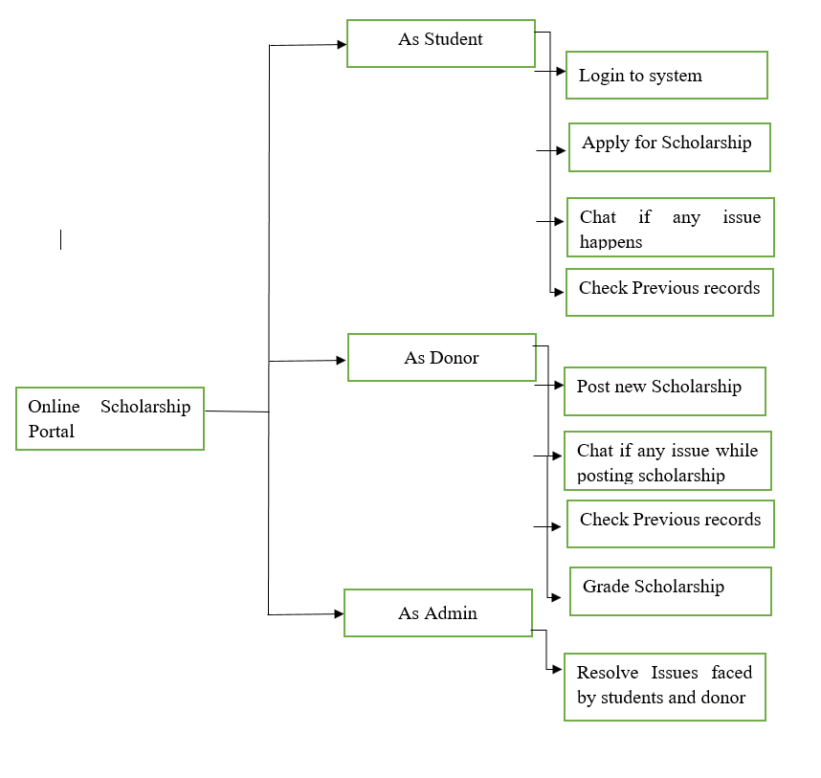

## 4.2. Use Cases

## 4.2.1. Student Module.

Use Case Diagram



Use Case Description

1.1 Login and Sign up to application

|  |  |  |  |  |
| --- | --- | --- | --- | --- |
| Login and Signup to application | | | | |
| ***Use case Id:*** | | 1.1 | | |
| ***Actors:*** Students of universities | | | | |
| ***Feature:*** Login and signup to application for applying or viewing previous records. | | | | |
| ***Pre-condition:*** | | 1. For user to login, student must have username and password. 2. For signup, user must have an active mobile number and email account for versification of account. | | |
| ***Scenarios*** | | | | |
| ***Step#*** | ***Action*** | | | ***Software Reaction*** |
| ***1.*** | Enter username and password for applying scholarship | | | Username and password must be validated from the database and |
| ***2.*** | Enter first name, last name , username, mobile number and email for sign up. | | | The system will send OTP to mobile number and the email address for the verification. |
|  | Enter for forgot password | | | The system should send an OTP to mobile number or email in order to reset password |
| ***Alternate Scenarios:*** Write additional, optional, branching or iterative steps. Refer to specific action number to ensure understandability. | | | | |
| **1a:** Redirect user to the login page and show error message or notify with the message with cause of unsuccessful login.  **2a:** Shows error message if the course already exists in database. | | | | |
| ***Post Conditions*** | | | | |
| ***Step#*** | ***Description*** | | | |
| 1 | User will be logged in the system. | | | |
| 2. | Account will be created for the user after successful authentication through email and mobile number OTP. | | | |
| ***Use Case Cross referenced*** | | |  | |

1.2 Viewing posts related to scholarships.

|  |  |  |  |  |
| --- | --- | --- | --- | --- |
| **Viewing posts related to scholarships.** | | | | |
| ***Use case Id:*** | | 1.2 | | |
| ***Actors:*** Students of Universities | | | | |
| ***Feature:*** Viewing Scholarship ads and viewing details related to particular scholarship. | | | | |
| ***Pre-condition:*** | | User must be logged in to the system in order to provide security of system. | | |
| ***Scenarios*** | | | | |
| ***Step#*** | ***Action*** | | | ***Software Reaction*** |
| ***1.*** | View ad for scholarship. | | | System must provide functionality to the actor for viewing post time by time. |
| ***2.*** | Click on ad to see full details. | | | System must redirect user to the new window for viewing full datils of scholarship. |
|  |  | | |  |
| ***Alternate Scenarios:*** | | | | |
| **1a:** Redirect user to the login page and show error message or notify with the message with cause of unsuccessful login.  **2a:** Shows error message if the user clicks on an ad whose date has already passed | | | | |
| ***Post Conditions*** | | | | |
| ***Step#*** | ***Description*** | | | |
| 1 | User will be viewing the details of scholarships announced and which scholarships will be announced next. | | | |
| 2. | The user will be getting full knowledge | | | |
| ***Use Case Cross referenced*** | | |  | |

1.3 Applying for any scholarship.

|  |  |  |  |  |
| --- | --- | --- | --- | --- |
| Applying for any scholarship. | | | | |
| ***Use case Id:*** | | 1.3 | | |
| ***Actors:*** Students of Universities | | | | |
| ***Feature:*** Applying for a scholarship, filling form by accessing web link. | | | | |
| ***Pre-condition:*** | | User must be logged in to the system in order to provide security of system. | | |
| ***Scenarios*** | | | | |
| ***Step#*** | ***Action*** | | | ***Software Reaction*** |
| ***1.*** | Getting user details related to any scholarship. | | | Data will be entered and saved to the database |
| ***2.*** | Submit application form at the end | | | The system will send a conformation message to the user and will be short list students based on given criteria. |
| ***Alternate Scenarios:*** | | | | |
| **1:** Redirect user to the login page and show error message or notify with the message with cause of unsuccessful login.  **2:** Shows error message if the data related to any field is incorrect.  3: Show error message if the at the submission of application occurs any error. | | | | |
| ***Post Conditions*** | | | | |
| ***Step#*** | ***Description*** | | | |
| 1 | The application of the form will be submitted and data will be saved to the database. | | | |
| 2. | The selection of student students will be done based on criteria by the system. Th e next selection will be done by the committee. | | | |
| ***Use Case Cross referenced*** | | |  | |

1.4 Viewing data of previous scholarships.

|  |  |  |  |  |
| --- | --- | --- | --- | --- |
| Viewing data of previous scholarships. | | | | |
| ***Use case Id:*** | | 1.4 | | |
| ***Actors:*** Students of Universities | | | | |
| ***Feature:*** Viewing data of applied scholarships and viewing feedback about them | | | | |
| ***Pre-condition:*** | | User must be logged in to the system in order to provide security of system. | | |
| ***Scenarios*** | | | | |
| ***Step#*** | ***Action*** | | | ***Software Reaction*** |
| ***1.*** | Viewing data of previous scholarship. | | | The system will retrieve data from database and show data to the student. |
| ***2.*** | View feedback from the committee about scholarship. | | | The system will be showing feedback to the student from the committee. |
| ***Alternate Scenarios:*** | | | | |
| **1:** Redirect user to the login page and show error message or notify with the message with cause of unsuccessful login.  **2:** Shows error message if the donor has not allowed to view for previous scholarship.  3: Show error message if the feedback id not available for any student | | | | |
| ***Post Conditions*** | | | | |
| ***Step#*** | ***Description*** | | | |
| 1 |  | | | |
| 2. |  | | | |
| ***Use Case Cross referenced*** | | |  | |

1.5 Resolving issue for students while filling scholarship application.

|  |  |  |  |  |
| --- | --- | --- | --- | --- |
| Resolving issue for students while filling scholarship application. | | | | |
| ***Use case Id:*** | | 1.5 | | |
| ***Actors:*** Students, Admin and Donor | | | | |
| ***Feature:*** Resolving issues of students, admin and donor will help to resolve issues. | | | | |
| ***Pre-condition:*** | | User must be logged in to the system in order to provide security of system. | | |
| ***Scenarios*** | | | | |
| ***Step#*** | ***Action*** | | | ***Software Reaction*** |
| ***1.*** | The problem faced by student and solved by admin. | | | The chat app will connect admin to the student and listen to issues and solves them. |
| ***2.*** | The problem solved by the donor of scholarship. | | | The chat app will connect admin to the student and listen to issues and solves them. |
| ***Alternate Scenarios:*** | | | | |
| **1:** Redirect user to the login page and show error message or notify with the message with cause of unsuccessful login.  **2:** Shows error message if the data related to any field is incorrect.  3: Show error message if the at the submission of application occurs any error. | | | | |
| ***Post Conditions*** | | | | |
| ***Step#*** | ***Description*** | | | |
| 1 | The problem will be solved and the any issue related to applying will be entertained if any. | | | |
| 2. | The chat app will be new when ever user again wants to interact with the admin or the donor. | | | |
| ***Use Case Cross referenced*** | | |  | |

### 4.2.2. Donor

**Use Case Diagram**

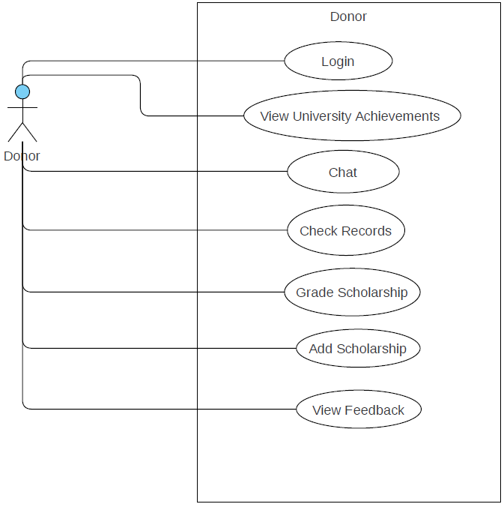

**Use Case Description**

**Login**

|  |  |  |  |  |
| --- | --- | --- | --- | --- |
| **login** | | | | |
| ***Use case Id:*** | | 4.2.1 | | |
| ***Actors:*  Donor** | | | | |
| ***Feature:***  Authentication | | | | |
| ***Pre-condition:*** | | Donor has to register first in order to get the credential via system. | | |
| ***Scenarios*** | | | | |
| ***Step#*** | ***Action*** | | | ***Software Reaction*** |
| ***1.*** | Enter username and password to login to the system. | | | System shall validate login information of the user. |
| ***2.*** | User click on the login button | | | If validated then it donor is directed to its main dash board. |
| ***3.*** | User Click on Forget password | | | System will redirect to restore password page. |
| ***Alternate Scenarios:*** | | | | |
| **1a:** If user provides invalid credentials then 3.  **2a:** User is asked to try again. | | | | |
| ***Post Conditions*** | | | | |
| ***Step#*** | ***Description*** | | | |
| **1** | Donor can perform any activities like checking records, posting/adding scholarship, chatting with admin, grading scholarship, viewing feedback, viewing achievements of university. | | | |
| ***Use Case Cross referenced*** | | | None | |

* + 1. **View University Achievements**

|  |  |  |  |  |
| --- | --- | --- | --- | --- |
| **View University Achievements** | | | | |
| **Use case Id:** | | 4.2.2 | | |
| **Actors:**  Donor | | | | |
| **Feature:** See achievement of university like scholarship sponsor, donors | | | | |
| **Pre-condition:** | | Donor has to login first via account credential. | | |
| **Scenarios:** | | | | |
| **Step#** | **Action** | | | **Software Reaction** |
| **1.** | Enter username and password to login to the system. | | | System shall validate login information of the user. |
| **2.** | See different scholarship achievement which students are availed. | | | System will show the different achievements of scholarship what students has availed and what are they availing. |
| **Alternate Scenarios:** | | | | |
| **1a:** Redirect user to the login page and show error message or notify with the message with cause of unsuccessful login.  **2a:** User will see the achievement of institution. | | | | |
| **Post Conditions** | | | | |
| **Step#** | **Description** | | | |
| **1** | User is logged in to the system with valid account. | | | |
| **2** | See and view the achievement | | | |
| **Use Case Cross referenced** | | | None | |

**Chat**

|  |  |  |  |  |
| --- | --- | --- | --- | --- |
| **4.2.3 Chat** | | | | |
| **Use case Id:** | | 4.2.1.3 | | |
| **Actors:**  Donor | | | | |
| **Feature:** Chat | | | | |
| **Pre-condition:** | | Donor has to login first via account credential. | | |
| **Scenarios:** | | | | |
| **Step#** | **Action** | | | **Software Reaction** |
| **1.** | Enter username and password to login to the system. | | | System shall validate login information of the user. |
| **2.** | User has accessibility to discuss with admin via chat feature on any topic. | | | System will provide the chat module. |
| **Alternate Scenarios:** | | | | |
| **1a:** Redirect user to the login page and show error message or notify with the message with cause of unsuccessful login.  **2a:** User can chat with admin in order to solve any problems or can ask details of institutes. | | | | |
| **Post Conditions** | | | | |
| **Step#** | **Description** | | | |
| **1** | Donor is logged into system with their credential. | | | |
| **2** | Can discuss any issue, problems, or can ask any query via chat module | | | |
| **Use Case Cross referenced** | | | None | |

**Check Records**

|  |  |  |  |  |
| --- | --- | --- | --- | --- |
| **Check Records** | | | | |
| **Use case Id:** | | 4.2.5 | | |
| **Actors:**  Donor | | | | |
| **Feature:** See records of student to whom scholarship is awarded, availing. | | | | |
| **Pre-condition:** | | Donor has to login first via account credential. | | |
| **Scenarios:** | | | | |
| **Step#** | **Action** | | | **Software Reaction** |
| **1.** | Enter username and password to login to the system. | | | System shall validate login information of the user. |
| **2.** | See the records of students who got the scholarship. | | | System will show the records of students who are awarded scholarship and availing the scholarship. |
| **3.** | Track the students who is still availing scholarship or not. | | | System will give access to see the records of students, and check specific student to ensure about whether student is still availing the scholarship or not. |
| **Alternate Scenarios:** | | | | |
| **1a:** Redirect user to the login page and show error message or notify with the message with cause of unsuccessful login.  **2a:** Donor will have capability to check records of students who are awarded scholarship  **3a:** Donor has also capability to track student whether student is still meeting with criteria or not. | | | | |
| **Post Conditions** | | | | |
| **Step#** | **Description** | | | |
| **1.** | User is logged in to the system with valid account. | | | |
| **2.** | This feature will enable the donor to see the records of students to whom scholarships are, currently, awarded. And can also previous records of students who have been awarded scholarship. | | | |
| **3.** | Donor can track the student means to see whether student is still availing scholarship or not. | | | |
| **Use Case Cross referenced** | | | None | |

**Grade Scholarship**

|  |  |  |  |  |
| --- | --- | --- | --- | --- |
| **Grade Scholarship** | | | | |
| **Use case Id:** | | 4.2.1.5 | | |
| **Actors:**  Donor | | | | |
| **Feature:** Grading Scholarship to those student who applied for posted scholarship | | | | |
| **Pre-condition:** | | Donor has to login first via account credential. | | |
| **Scenarios:** | | | | |
| **Step#** | **Action** | | | **Software Reaction** |
| **1.** | Enter username and password to login to the system. | | | System shall validate login information of the user. |
| **2.** | Donor have capability to grade on the basis of predefine criteria of posted scholarship that is announced. | | | System will allow the Donor to mark and assign the weightage of the scholarship, on the basis of certain criteria that is defined by donor, to student who applied for that. |
| **Alternate Scenarios:** | | | | |
| **1a:** Redirect user to the login page and show error message or notify with the message with cause of unsuccessful login. | | | | |
| **Post Conditions** | | | | |
| **Step#** | **Description** | | | |
| **1.** | After grading, the score will be stored the database for further processing. | | | |
| **2.** | Feedback will be given to each student based on the performance and credentials provided in the form. | | | |
| **Use Case Cross referenced** | | | None | |

**Add/Post Scholarship**

|  |  |  |  |  |
| --- | --- | --- | --- | --- |
| **4.2.1: Add/Post Scholarship** | | | | |
| **Use case Id:** | | 4.2.1.6 | | |
| **Actors:**  Donor | | | | |
| **Feature:** Post or Add Scholarship | | | | |
| **Pre-condition:** | | Donor has to login first via account credential. | | |
| **Scenarios:** | | | | |
| **Step#** | **Action** | | | **Software Reaction** |
| **1.** | Enter username and password to login to the system. | | | System shall validate login information of the user. |
| **2.** | Donor can post/Add scholarship and its criteria. | | | System will enable the Donor to post or add the scholarship. |
| **Alternate Scenarios:** | | | | |
| **1a:** Redirect user to the login page and show error message or notify with the message with cause of unsuccessful login.  **2a:** Enable donor to chat with admin if any error occurs while posting scholarship. | | | | |
| **Post Conditions** | | | | |
| **Step#** | **Description** | | | |
| **1.** | The notification to every registered student will be sent regarding scholarship.(edited) | | | |
| **2.** | This feature will enable the donor to add or post the scholarship and its details related to its criteria. The student can apply for scholarship based on given requirements. | | | |
| **Use Case Cross referenced** | | | None | |

**View Feedback**

|  |  |  |  |  |
| --- | --- | --- | --- | --- |
| **4.2.1: View Feedback** | | | | |
| **Use case Id:** | | 4.2.1.7 | | |
| **Actors:**  Donor | | | | |
| **Feature:** Feedback of students related to scholarship | | | | |
| **Pre-condition:** | | Donor has to login first via account credential. | | |
| **Scenarios:** | | | | |
| **Step#** | **Action** | | | **Software Reaction** |
| **1.** | Enter username and password to login to the system. | | | System shall validate login information of the user. |
| **2.** | Donor can see the view point of student related to scholarships that will show the feedback. | | | System will allow the donor to check and see the feedbacks of student that will be related to scholarship. |
| **Alternate Scenarios:** | | | | |
| **1a:** Redirect user to the login page and show error message or notify with the message with cause of unsuccessful login. | | | | |
| **Post Conditions** | | | | |
| **Step#** | **Description** | | | |
| **1.** | User is logged in to the system via its credential. | | | |
| **Use Case Cross referenced** | | | None | |

### 4.2.2. Admin

**Use Case Diagram**

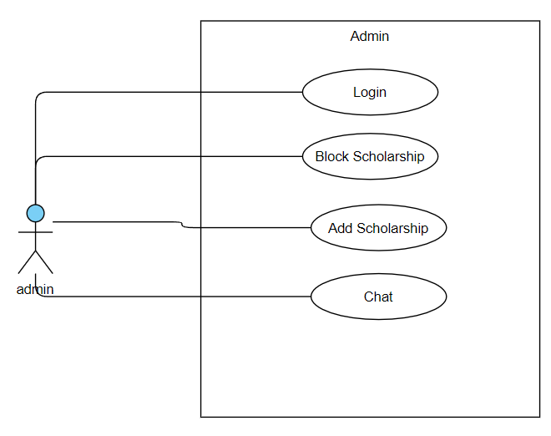

**Use Case Description**

1. **Login**

|  |  |  |  |  |
| --- | --- | --- | --- | --- |
| **4.2.2.1: login** | | | | |
| ***Use case Id:*** | | 4.2.2 | | |
| ***Actors:*** Admin | | | | |
| ***Feature:***  Authentication | | | | |
| ***Pre-condition:*** | | Admin has to register as a role of ADMIN so that it | | |
| ***Scenarios*** | | | | |
| ***Step#*** | ***Action*** | | | ***Software Reaction*** |
| ***1.*** | Enter username and password to login to the system. | | | System shall validate login information of the user. |
| ***2.*** | User click on the login button | | | If validated then it donor is directed to its page |
| ***3.*** | User Click on Forget password | | | System will redirect to restore password page. |
| ***Alternate Scenarios:*** | | | | |
| **1a:** If user provides invalid credentials then 3.  **2a:** User is asked to try again. | | | | |
| ***Post Conditions*** | | | | |
| ***Step#*** | ***Description*** | | | |
| **1** | User is authenticated and is allowed to use the system. | | | |
| ***Use Case Cross referenced*** | | | None | |

1. **Verify Scholarship**

|  |  |  |  |  |
| --- | --- | --- | --- | --- |
| **4.2.2.2: Add Scholarship** | | | | |
| **Use case Id:** | | 4.2.2 | | |
| **Actors:**  Admin | | | | |
| **Feature:** Add Scholarship after verification, When posted/Added scholarship from Donor | | | | |
| **Pre-condition:** | | Donor has to post scholarship so that admin can verify it. | | |
| **Scenarios:** | | | | |
| **Step#** | **Action** | | | **Software Reaction** |
| **1.** | Enter username and password to login to the system. | | | System shall validate login information of the user. |
| **2.** | Admin can add, check and verify the scholarship that is added/posted by donor. | | | System will enable the admin to add the scholarship after checking and verifying. |
| **Alternate Scenarios:** | | | | |
| **1a:** Redirect user to the login page and show error message or notify with the message with cause of unsuccessful login.  **2a:** Admin will have authority to add Scholarship after posted/added via donor so that student can see and check the scholarship. If there is any error, or miss-information in the scholarship then Donor will be informed so that to correct. | | | | |
| **Post Conditions** | | | | |
| **Step#** | **Description** | | | |
| **1.** | User is logged in to the system with valid account. | | | |
| **2.** | This feature will enable the ADMIN to add, check and verify the scholarship properly so that student could not face any problem regarding that, and the information that is required in scholarship can be verified. | | | |
| **Use Case Cross referenced** | | | None | |

1. Block Scholarship

|  |  |  |  |  |
| --- | --- | --- | --- | --- |
| **Block Scholarship** | | | | |
| **Use case Id:** | | 4.2.2.3 | | |
| **Actors:** Admin | | | | |
| **Feature:** Blocking Scholarship because of any issues/trouble | | | | |
| **Pre-condition:** | | Donor has to post/Add scholarship and it will be verified by admin. After checking the scholarship, later any things is realized that anything is not as against per requirements then it can be block. | | |
| **Scenarios:** | | | | |
| **Step#** | **Action** | | | **Software Reaction** |
| **1.** | Enter username and password to login to the system. | | | System shall validate login information of the user. |
| **2.** | Posted/Added Scholarship can be block via admin if there is any miss-information or there is any problems. | | | System will enable the admin to Block the scholarship. |
| **Alternate Scenarios:** | | | | |
| **1a:** Redirect user to the login page and show error message or notify with the message with cause of unsuccessful login.  **2a:** Admin will have authority to Block Scholarship after posted/added via donor if there is any problems or miss-information so that student could not face any miss-leading information means that if there is any error, or miss-information in the scholarship then admin will block it. | | | | |
| **Post Conditions** | | | | |
| **Step#** | **Description** | | | |
| **1.** | User is logged in to the system with valid account. | | | |
| **2.** | User will not apply for the post of scholarships as a donor. The current donor will be blocked. | | | |
| **Use Case Cross referenced** | | | None | |

1. Chat

|  |  |  |  |  |
| --- | --- | --- | --- | --- |
| **4.2.2:Chat** | | | | |
| **Use case Id:** | | 4.2.2.4 | | |
| **Actors:**  Admin, Student, Donor. | | | | |
| **Feature:** Chat | | | | |
| **Pre-condition:** | | Admin has been login via account credential. | | |
| **Scenarios:** | | | | |
| **Step#** | **Action** | | | **Software Reaction** |
| **1.** | Enter username and password to login to the system. | | | System shall validate login information of the user. |
| **2.** | Admin has accessibility, authority to solve queries of students as well as Donors if they are facing any problems, via chat module. | | | System will provide the chat module so that admin can discuss, solve, handle the queries of students as well as donors. |
| **Alternate Scenarios:** | | | | |
| **1a:** Redirect user to the login page and show error message or notify with the message with cause of unsuccessful login.  **2a:** Admin can chat with donor/student in order to solve any problems or can ask help if they needed while filling ,posting, processing and grading applications. | | | | |
| **Post Conditions** | | | | |
| **Step#** | **Description** | | | |
| **1** | N/A | | | |
| **2** | N/A | | | |
| **Use Case Cross referenced** | | | None | |

# 5. Non-functional Requirements

## 5.1. Performance Requirements

*[The performance characteristics of the system that are required by the business should be outlined in this section. Performance characteristics include the speed, precision, concurrency, capacity, safety, and reliability of the software. These characteristics define the performance of the project.]*

Performance describes how fast system responds. Following requirements are associated with the performance of the system:

**5.1.1 Response Time**:

System shall take minimum load time depending on client’s internet i.e.,2 to 5 seconds.

## 5.2. Safety Requirements

*[Specify the requirements that are concerned with possible loss, damage, or harm that could result from the use of the system. Define any safeguards or actions that must be taken, as well as potentially dangerous actions that must be prevented. Identify any safety certifications, policies, or regulations to which the system must conform.]*

Safety requirements are those requirements that are associated with the degree to which system does not cause harm to life or property:

1. System shall not lose user account information.
2. The system should not be capable enough to tackle with DoS attacks.
3. The system should not lose any of student, donor or admin data to such person that has no identification to system.
4. The system should calculate correct grades for students at the time of grading application.

## 5.3. Security Requirements

*[Specify any requirements regarding security, integrity, or privacy issues that affect the use of the system and protection of the data used or created by the system. Define all user authentication or authorization requirements, if any. Identify any security or privacy policies or certifications the system must satisfy.]*

These requirements are those requirements that specify the extent to which system protects itself from unauthorized access, use and modification.

**5.3.1 Authentication requirements:**

1. The system authenticate student every time whenever student
   1. Wants to apply for any scholarship.
   2. Check previous records for applied scholarships.
   3. Having chat with admin or donor while having issue in filling scholarships.
2. The system authenticate admin whenever admin
   1. Want to authenticate donor to donate scholarship
   2. Want to block donors with fake intention to donate scholarship.
   3. Want to have chat with student or donor to solve issues in order to improve the process of management of scholarship.
3. The system should authenticate donor whenever donor
   1. Want to post any scholarships.
   2. Want to grade scholarships of applied applications.
   3. Want to check previous records of students.
   4. Want to solve issues of students while filling forms.

**5.3.2 Authorization Requirements**:

1. System shall authorize Admin before allowing it access to the use cases for which it is authorized.
2. System shall notify admin if a user tries to perform a task for which it is unauthorized.
3. System shall automatically log out the user if no activity is detected from it for 5 minutes and ask for credentials if the activity is detected again.

**5.3.3 Privacy Requirements:**

1. System shall not display password on screens.
2. System shall restrict the user information to only the user and admin including:

* Postal information
* Telephone information
* Password information

## 5.4. User Documentation

*[List the user documentation components that will be delivered along with the software, such as user manuals, online help, context-sensitive help and tutorials.]*

# 6. References

|  |  |
| --- | --- |
| [1] | "https://ehsaas.hec.gov.pk/#/login," [Online]. |
| [2] | W.-K. Shen, "An Online Scholarship Application System," 2011. |
| [3] | M. N. M. T. Mohammed Abdullahi Jibrin, "Development of E-Scholarship System". |
| [4] | "https://play.google.com/store/apps/details?id=com.brightscholarship.app," Bright Scholarship App. [Online]. |
| [5] | "https://play.google.com/store/apps/details?id=com.interscholarships.students," Scholarship for internation Students. [Online]. |
| [6] | "https://play.google.com/store/apps/details?id=in.gov.scholarships," National Scholarships. [Online]. |
| [7] | "https://play.google.com/store/apps/details?id=com.app.scholarship," Scholarship Home. [Online]. |
| [8] | "https://play.google.com/store/apps/details?id=com.shikhon.codecompiler.globalscholarship," Global Scholarship. [Online]. |
| [9] | "https://play.google.com/store/apps/details?id=com.scholly.scholarshipsearch," Scholly: College Scholarships. [Online]. |
| [10] | "https://play.google.com/store/apps/details?id=com.scholarships.pakistan," Scholarships in Pakistan. [Online]. |
| [11] | "https://play.google.com/store/apps/details?id=com.softsolutions.ilmkidunya.scholarships," Scholarships. [Online]. |